NUMBER | Service Number | NAME | Surname
RANK | RCT | SUB-UNIT | Pirbright

1. DISPOSAL *

FIT FOR FULL DUTIES

TRG LIMITATIONS (SEE BELOW) |  | For |  | Days | Or until

ENTRY DEFERRED AT IMA ** | X | For |  | wks | Or until

2. LIMITATIONS *

X = EXCUSED |  | N/A = Not applicable
= PERMITTED

SEDENTARY |  | CLASSROOM DUTIES ONLY
MILITARY EXERCISE |  | LOAD CARRYING
 |  | OBSERVATION ON EX - NO LOAD CARRYING
 |  | ADVENTURE TRAINING
WEAPON HANDLING |  | DCCT (COMPUTER SIMULATED RANGE)
 |  | OUTDOOR RANGE - STATIC
 |  | OUTDOOR RANGE – FIRE AND MANOEUVRE
 |  | WEAPON HANDLING LESSONS
 |  | LIVE FIRING
PHYSICAL TRG (PT) |  | UPPER BODY PT
 |  | LOWER BODY PT
 |  | RUNNING
 |  | BATTLE PT INCLUDING ASSAULT COURSE
 |  | SWIMMING
 |  | STATIC BIKE
 |  | CROSS-TRAINER
MILITARY PHYSICALTESTS |  | PFT / RMT / CFT
MARCHING |  | SQUADDED
 |  | INDIVIDUAL
DRILL |  | FOOT
 |  | ARMS
DRESS |  | BOOTS
 |  | HELMET
 |  | TRAINERS
KIT |  | PERSONAL DAYSACK
 |  | WEBBING
IMA Pending - their body composition is in serial 4 or 5 of the table from AGAI 40 (below). This is outside the standard required. They may attend the SDC provided they have passed all elements of RFT(E) (iaw HQ ARITC BMI Entry Standards MJP on 1 Dec 23)

CURRENT MEASUREMENTS
Weight Read Code Fields - 22A kg
Height Read Code Fields - 229 cm
BMI Read Code Fields - 22K kg/m²
Waist Circumference Read Code Fields - 22N0 cm

AGAI 40 Standards:

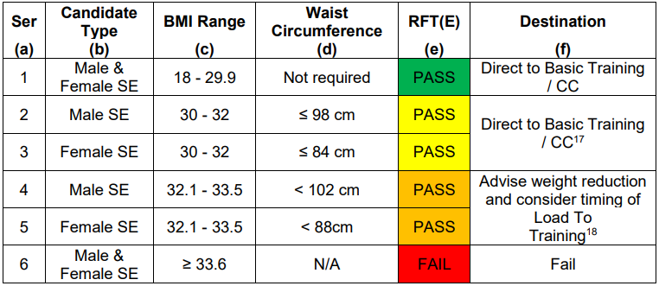

NAME AND RANK | User Title User Name | DATE | System Date
SIGNATURE |  | EXT
PLATOON/TROOP STAFF SIGNATURE |  | DATE
RECRUIT’S SIGNATURE |  | DATE

Medical Reception Station  ATR Pirbright  Alexander Barracks  Pirbright  WOKING  Surrey GU24 OQQ  Tel: 01483 798300 / (94211) 8333 | MEDICAL CENTRE STAMP | IMPORTANT
 | MED CENTRE  ATR PIRBRIGHT  ALEXANDER BKS  PIRBRIGHT  GU24 0QQ | Sub-unit staff are responsible for ensuring recruits are aware of and attend all medical appointments
 |  | COPIES
 |  | Recruit | FMed 4 | Sub-unit

